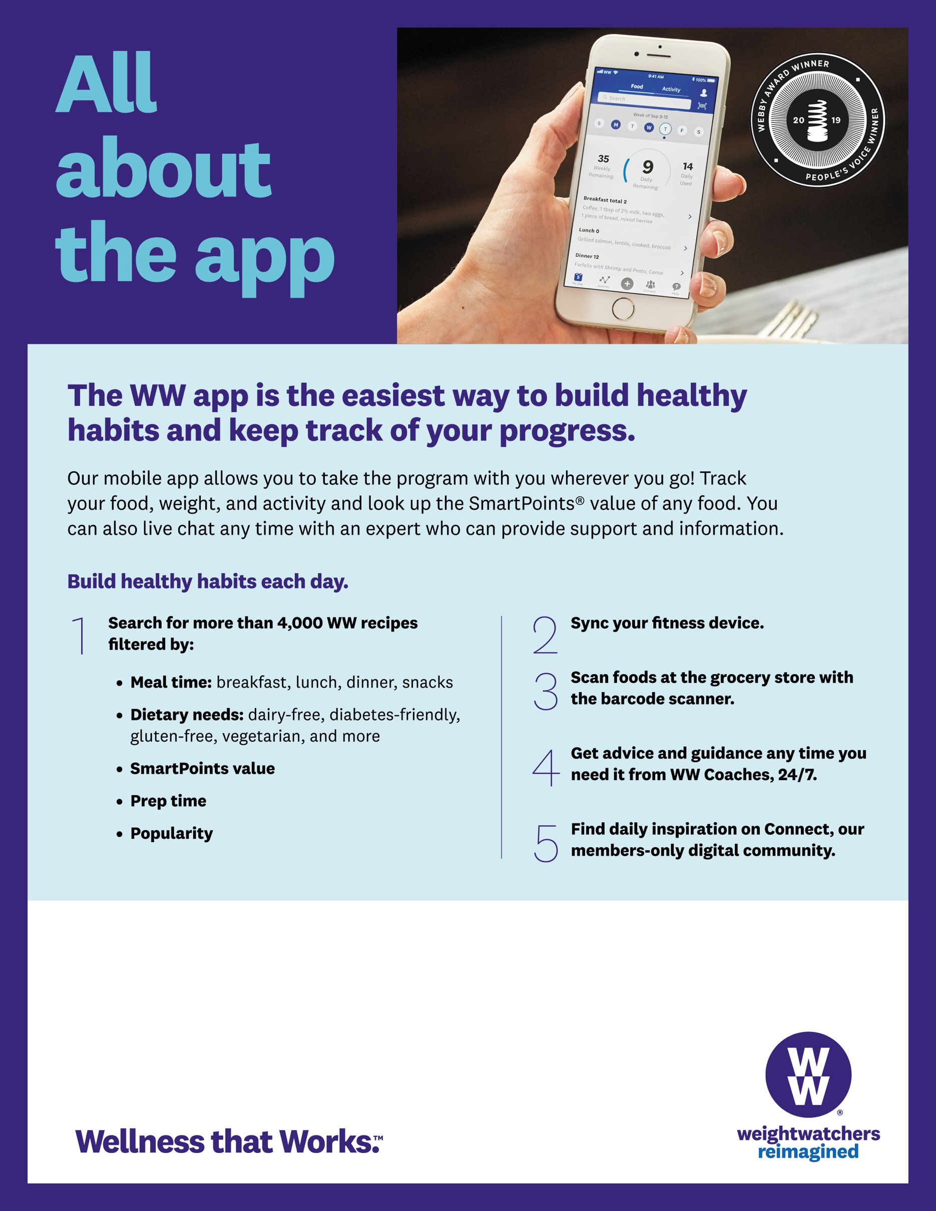

To view the **All About The App** **webinar,** go to **[URL**]

To sign up for WW today or to learn more, contact **Niki**  
at **715-340-5820** or **niki@weightwatchersaz.com**.

Employees can join WW Wellness Workshops in the workplace!

