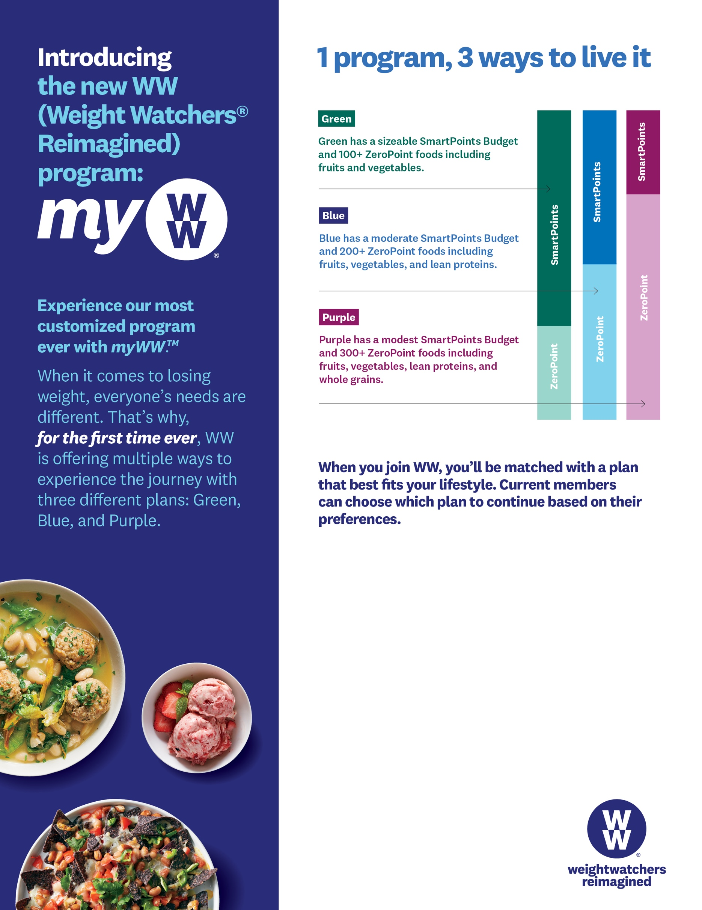

To sign-up for WW today or learn more, contact **Niki** at **715-340-5820** or **niki@weightwatchersaz.com.**

**Employees can join WW Workshops in the workplace!**

**Get started today!**

The WW Coin Logo, Weight Watchers, SmartPoints, ZeroPoint and myWW are the trademarks of WW International, Inc.

©2019 WW International, Inc. All rights reserved.