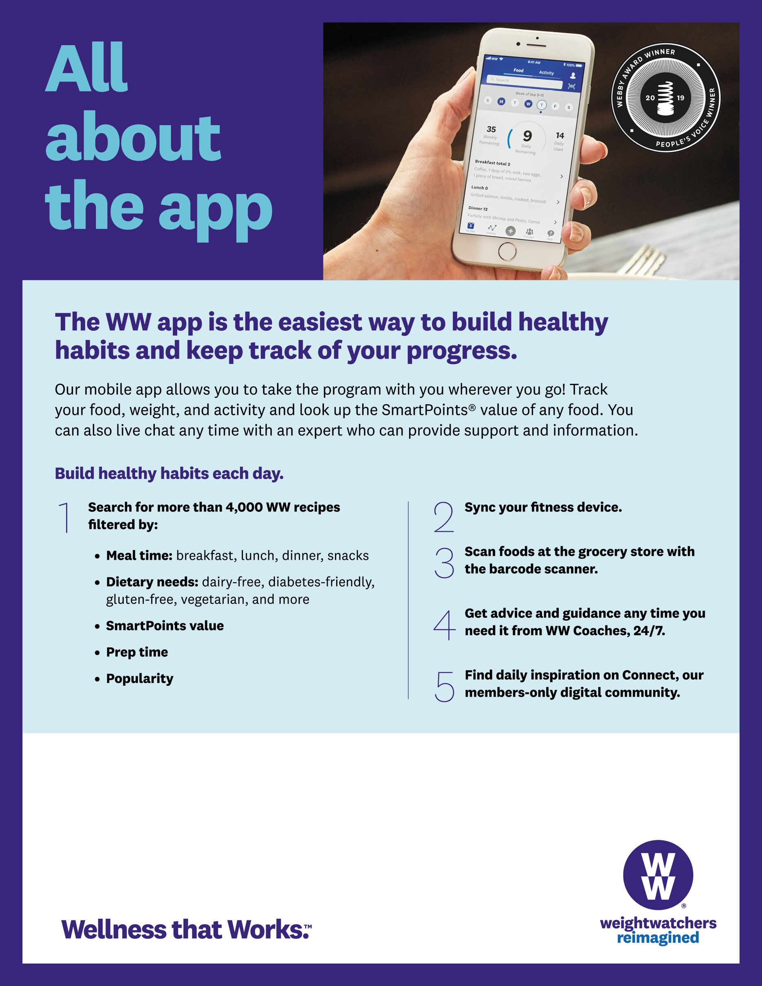

To sign up for WW today or to learn more, **Aaron** at **[**602-248-0303 ext. 122**]** or **aaron@weightwatchersaz.com**.

Employees can join WW Wellness Workshops & Webinars in the workplace!

