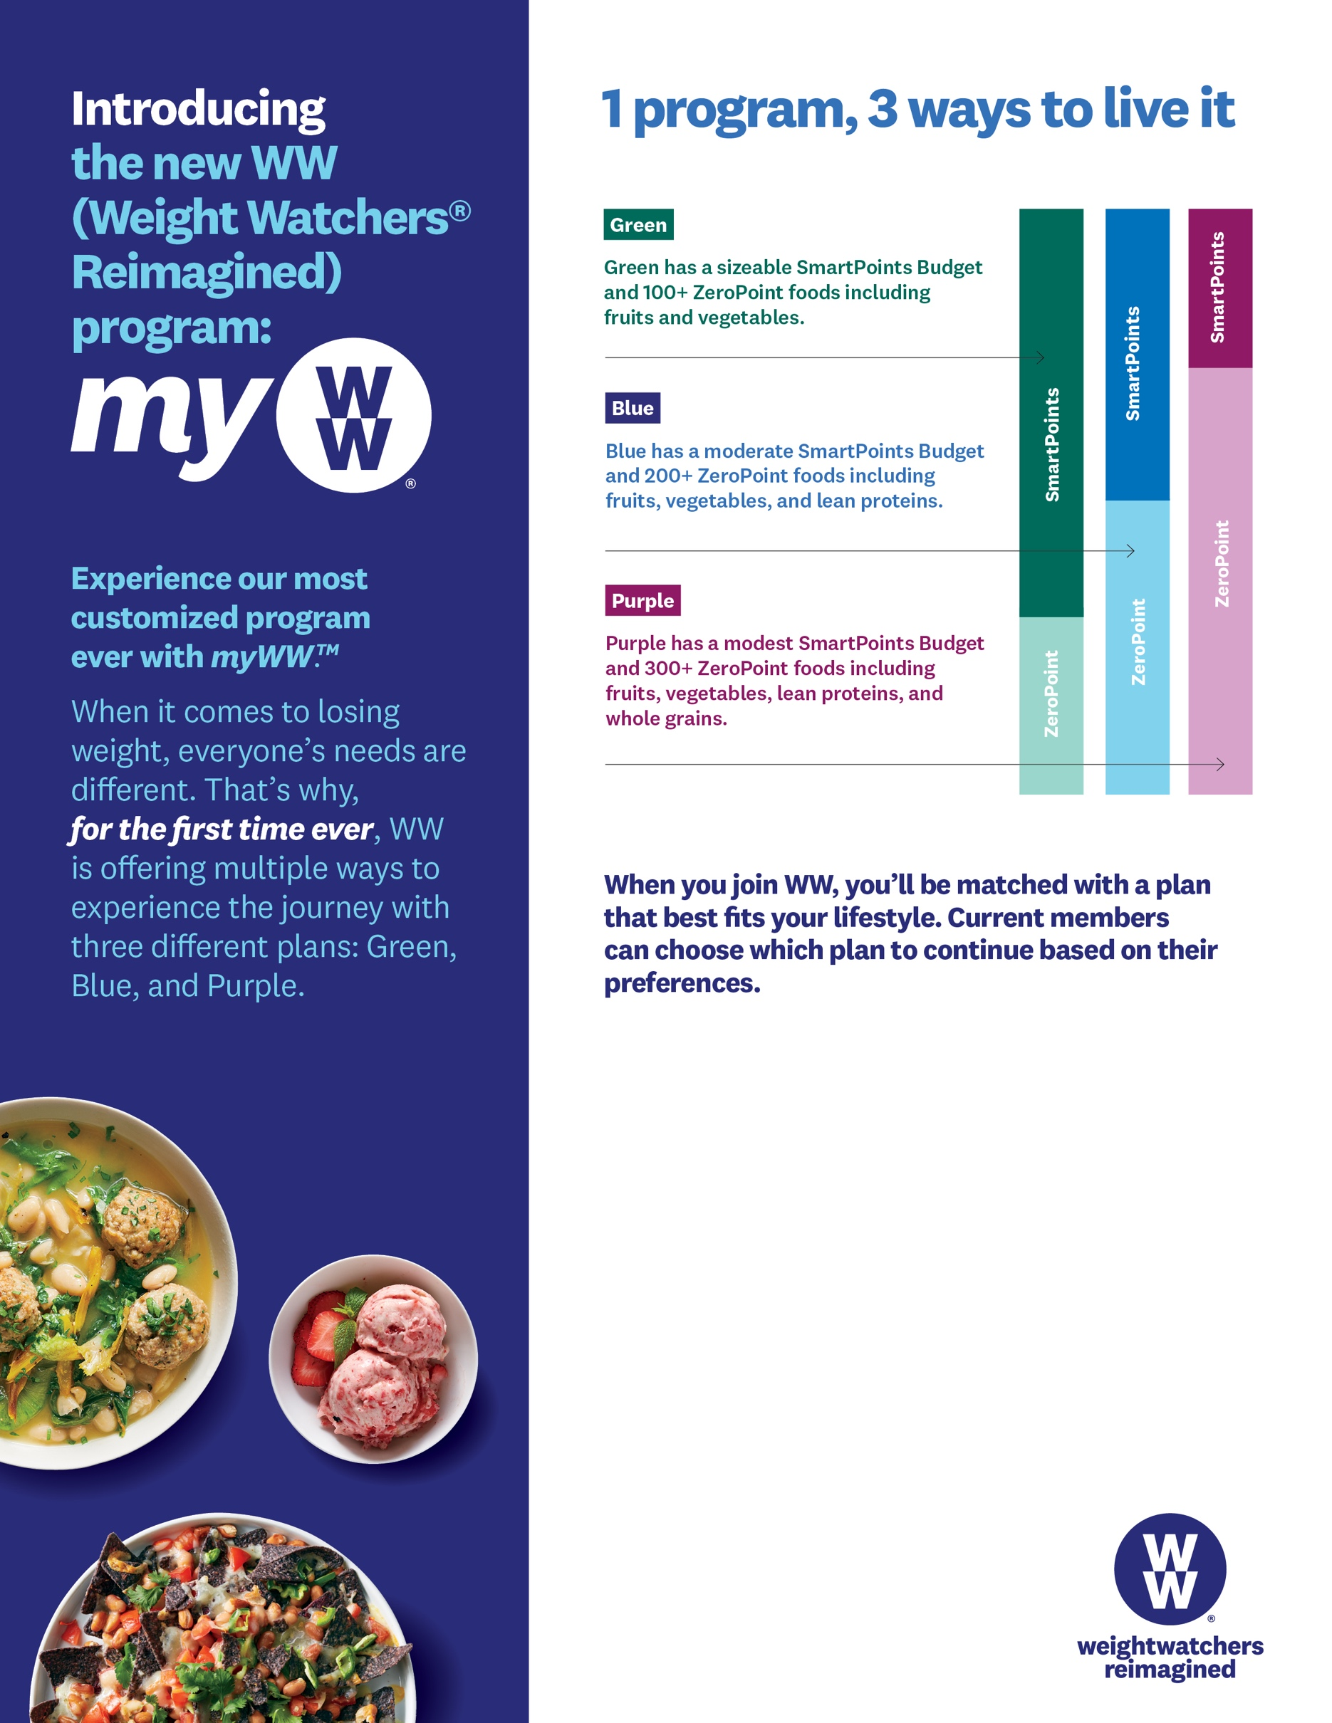

To sign-up for WW today or learn more, contact Aaron at [602-248-0303 ext. 122] or aaron@weightwatchersaz.com.

**Employees can join WW Workshops & Webinars in the workplace!**

**Get started today!**

The WW Coin Logo, Weight Watchers, SmartPoints, ZeroPoint and myWW are the trademarks of WW International, Inc.

©2019 WW International, Inc. All rights reserved.